Diocesan Council Meeting – June 26, 2021 – A Hybrid meeting at Camp Gabriel and on Zoom

- The Council meeting was convened by Bishop Ely at 10:00 AM
- Members present in person: Thomas Ely, Charlotte Peterson, John Floberg, Josh Floberg, Angela Goodhouse-Mauai, Elaine McLaughlin, Larry Thiele, Hal Weidman, Christie Iverson. Members present via Zoom: John Anderson, Amy Philips, Dan Rice, Donna Pettit, Terry Overbo, Mark Strobel, Tammy Enockson, Quinn Palmer, Leo Wilking. Member absent: Robert Fox, Peter Mading, Mary Ann Henry, Margaret Zaharia.
- The bishop welcomed everyone and invited each person to do a brief check-in and share something they are looking forward to this summer.
- Quinn Palmer offered the opening devotions.
- The bishop reviewed the RESPECT guidelines.
- Minutes of the May 22, 2021, meeting were approved.
- A discussion of the Mutual Ministry Matrix led to some suggested changes, which the bishop agreed to make and distribute to Council. This included the addition of one additional goal related to the formation of a New Season of Ministry Task Force. The Council gave its approval to the revisions, subject to final review and adoption at the August meeting.
- Amy Phillips and Dan Rice agreed to work with the bishop on a Convention resolution related to the Matrix and the creation of a New Season of Ministry Task Force.
- The meeting adjourned at 12:00 noon.

Respectfully submitted,
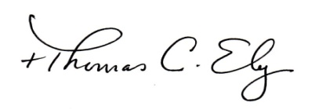
Thomas C. Ely (note: these minutes were recreated from available notes since the Secretary of the Council resigned before submitting official minutes).

