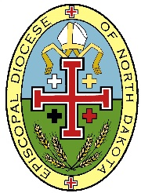
Episcopal Diocese of North Dakota
Photo Release

I hereby grant (CONGREGATION/EPISCOPAL DIOCESE OF NORTH DAKOTA) permission to use my likeness in a photograph or video in any and all publications, including website entries, without payment or any other consideration. I further understand and agree that these materials shall become the property of (CONGREGATION/EPISCOPAL DIOCESE OF NORTH DAKOTA) and will not be returned to me. I hereby authorize (CONGREGATION/EPISCOPAL DIOCESE OF NORTH DAKOTA) to edit, alter, copy, exhibit, publish, or distribute such photo or video for purposes of publicizing (CONGREGATION/EPISCOPAL DIOCESE OF NORTH DAKOTA) programs or for any other lawful purpose. In addition, I waive the right to inspect or approve the finished product, including written or electronic copy, wherein my likeness appears. I waive any right to royalties or other compensation arising or related to the use of such photograph or video.

____________________________________
Participant Signature

____________________________________
Participant Printed Name and Date

____________________________________
Parent/Guardian Signature

____________________________________
Parent/Guardian Printed Name and Date

